Fundamentos Web - Documentação

Nome: Elthon dos Santos Migotto - 193046

**Páginas do Site**

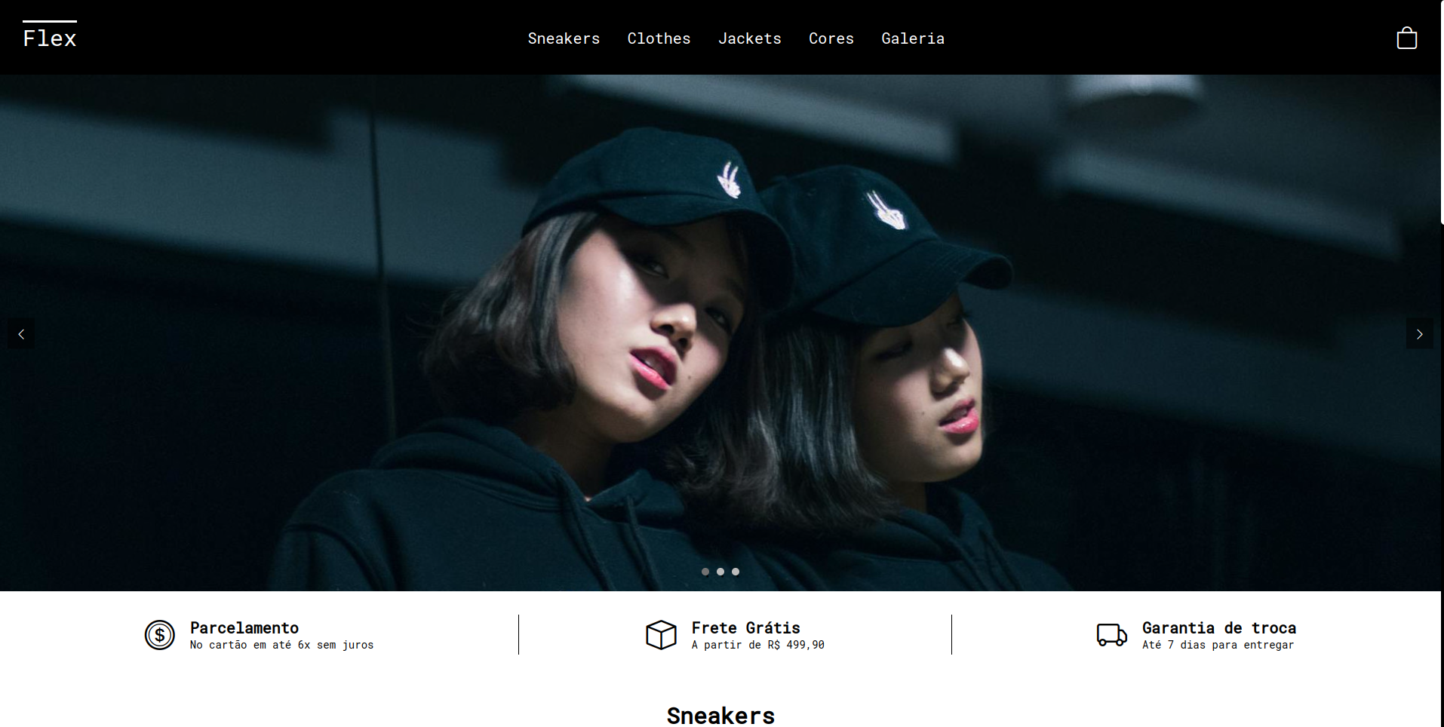

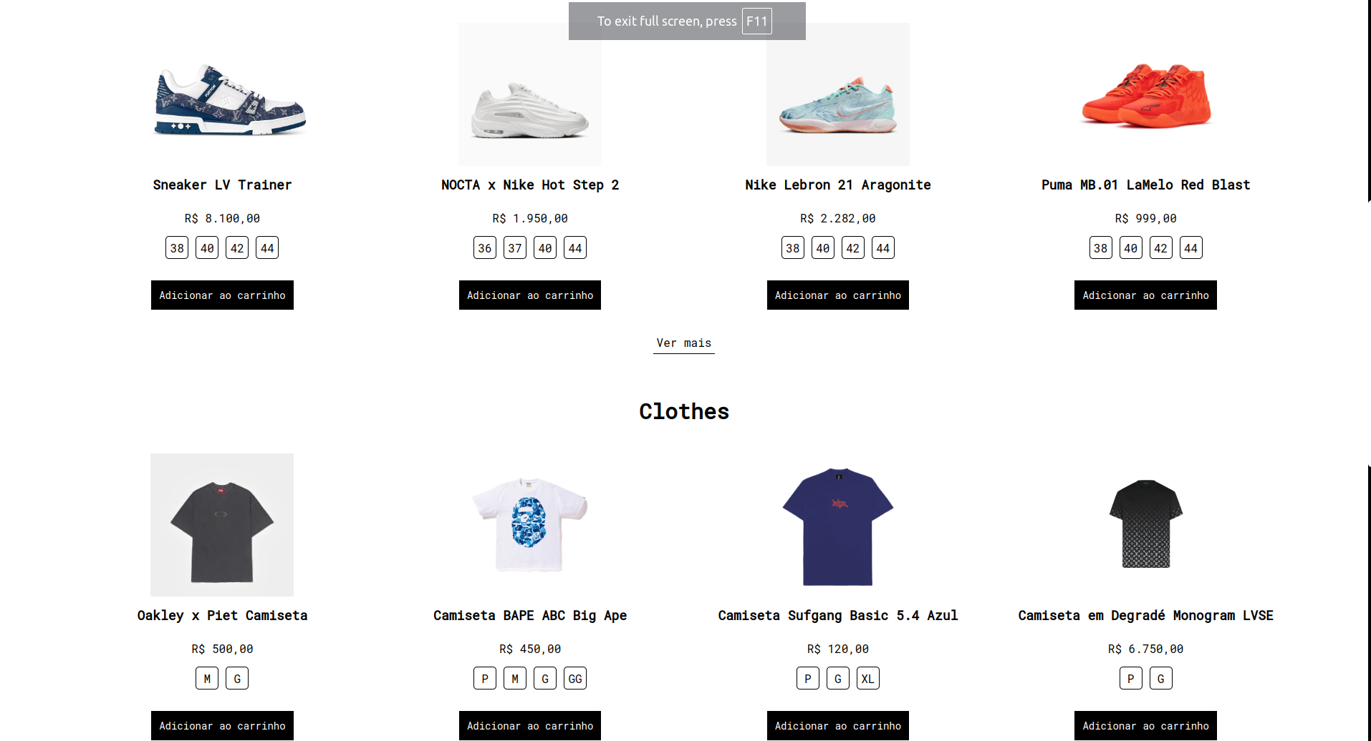

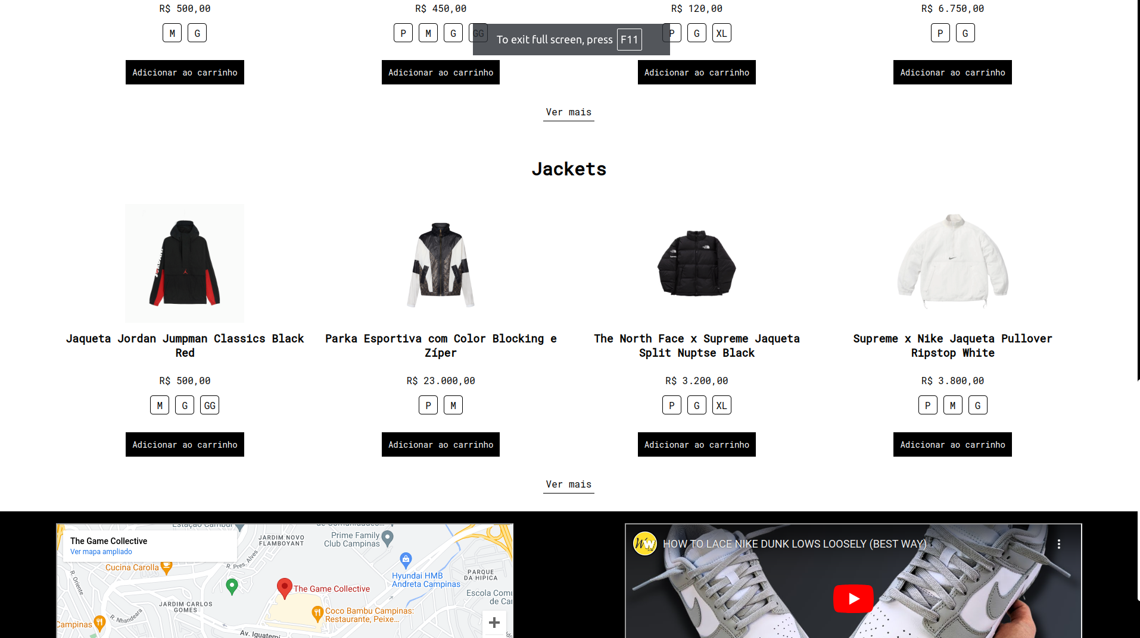

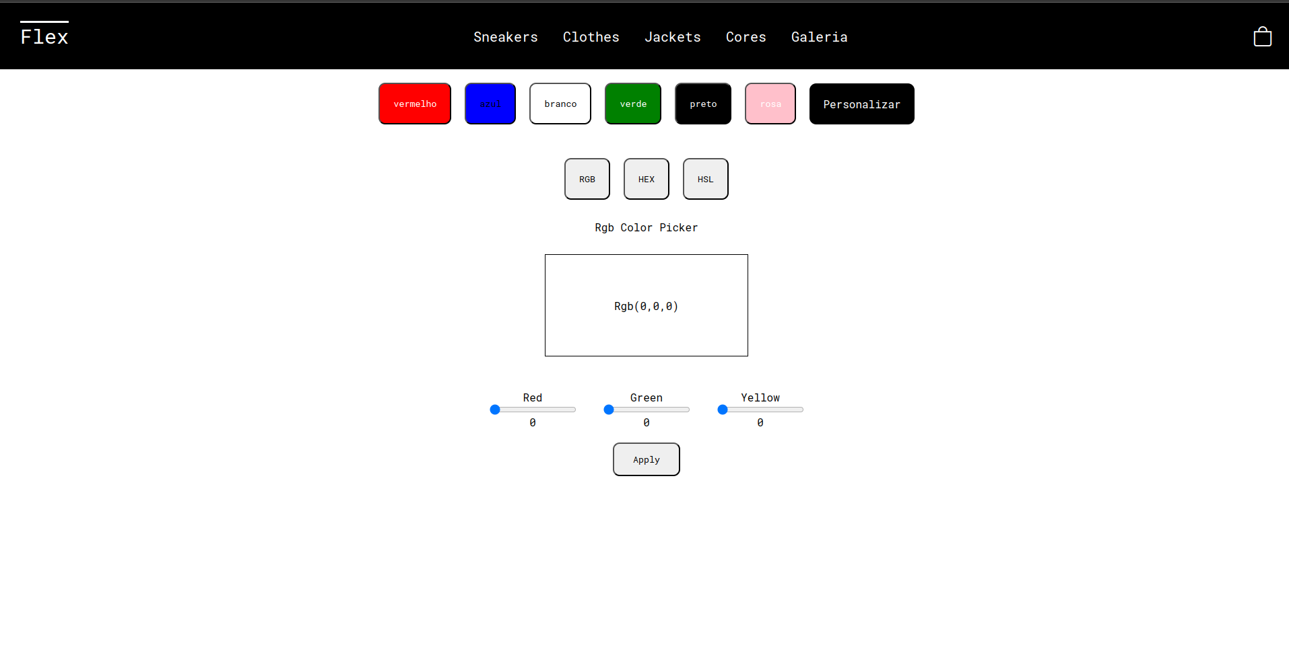

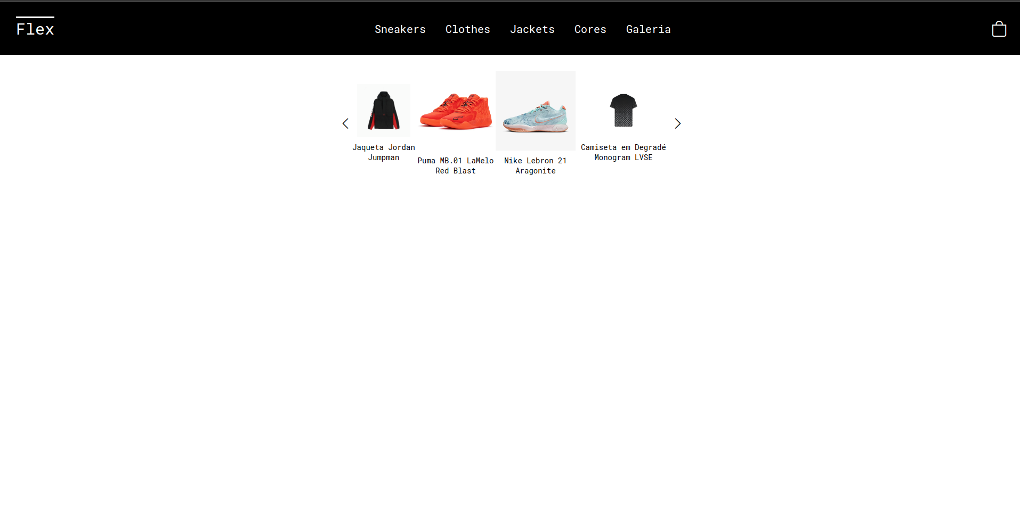

**Códigos**

index.html

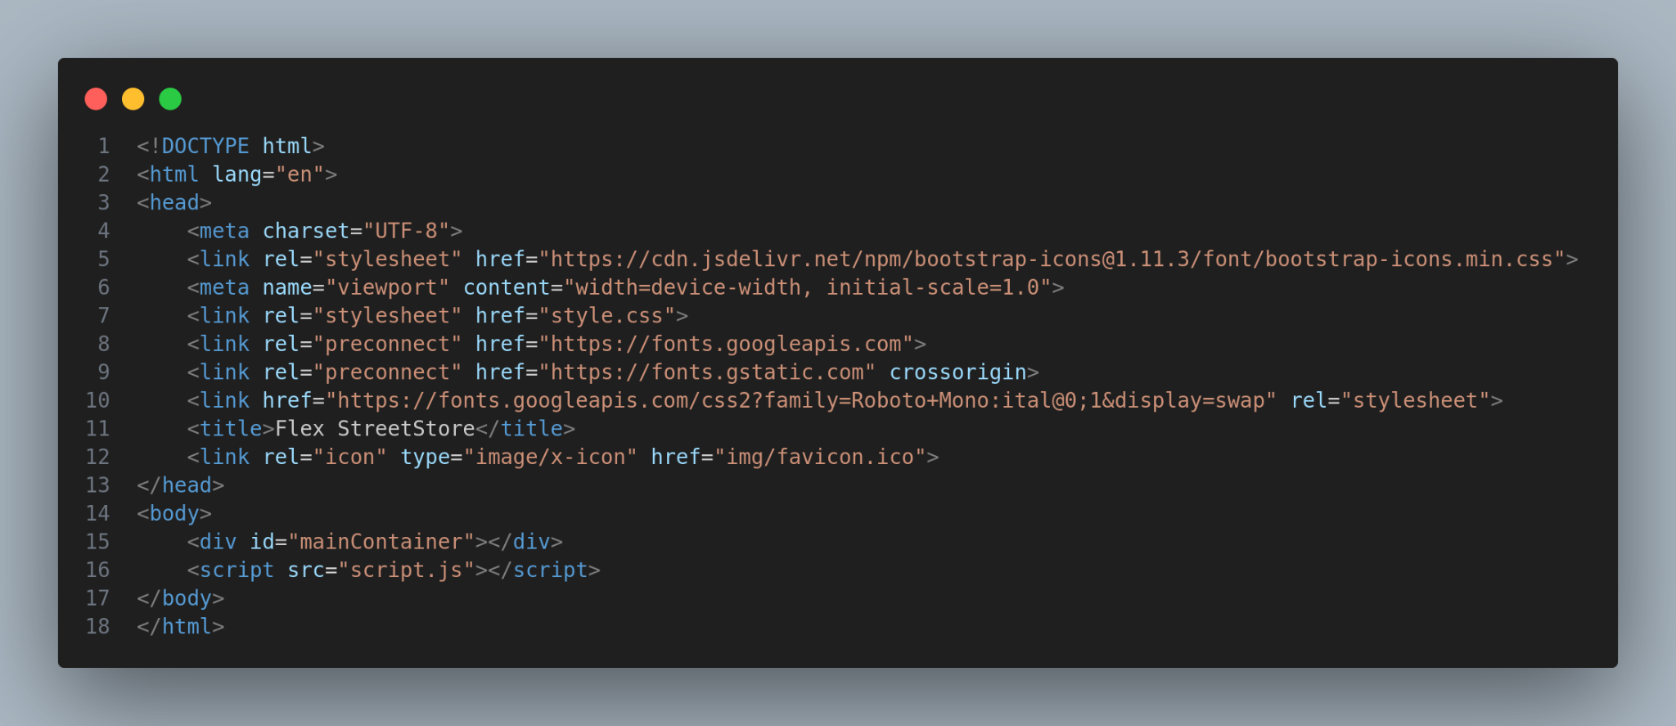

style.css

*{

padding: 0;

margin: 0;

font-family: "Roboto Mono", monospace;

}

body::-webkit-scrollbar{

width: 10px;

background-color: #000;

}

body::-webkit-scrollbar-thumb{

background-color: #FFF;

border-radius: 20px;

}

#mainContainer{

width: 100%;

height: 100%;

overflow-x: hidden;

}

.nav{

display: flex;

align-items: center;

justify-content: space-between;

background-color: #000;

}

.titleNav{

font-size: 30px;

padding: 30px;

color: #FFF;

text-decoration-line: overline;

}

.divAncor{

display: flex;

align-items: center;

width: 30%;

justify-content: space-between;

font-size: 20px;

}

.aNav{

cursor: pointer;

color: #FFF;

}

.aNav:hover{

color: #FFF;

text-decoration-line: underline;

}

.iNav{

font-size: 30px;

padding: 30px;

color: #FFF;

cursor: pointer;

}

/*slideshow styles*/

.divApresent{

width: 100%;

max-height: 750px;

overflow: hidden;

}

.imgApresent{

width: 100%;

object-fit: contain;

height: 100%;

}

.iSlideshow{

font-size: 50px;

color: #FFF;

position: absolute;

top: 42%;

}

.prev{

left: 0;

cursor: pointer;

}

.next{

right: 0;

cursor: pointer;

}

.iDots{

color: #FFF;

}

.iDot1{

bottom: 10%;

position: absolute;

font-size: 100px;

right: 50%;

}

.iDot2{

bottom: 10%;

position: absolute;

font-size: 100px;

right: 44%;

}

.iDot3{

bottom: 10%;

position: absolute;

font-size: 100px;

right: 38%;

}

.activeDot{

color: red;

}

.divInfos{

width: 100%;

height: 115px;

display: flex;

align-items: center;

justify-content: space-evenly;

}

.divInfo{

display: flex;

align-items: center;

justify-content: center;

}

#divFrete{

border-left: 1px solid black;

border-right: 1px solid black;

width: 30%;

}

.iconInfo{

font-size: 40px;

}

.divP{

padding-left: 20px;

}

.pInfoFirst{

font-size: 20px;

font-weight: 600;

}

.pInfoSecond{

font-size: 14px;

}

.divProduct{

width: 100%;

height: 500px;

}

.footer{

width: 100%;

height: 400px;

background-color: #000;

position: relative;

bottom: 0;

display: flex;

flex-direction: column;

align-items: center;

}

.map{

width: 40%;

height: 250px;

margin: 20px;

}

.divMap{

display: flex;

align-items: center;

justify-content: space-around;

width: 100%;

}

.video{

width: 40%;

height: 250px;

margin: 20px;

}

.divBottomFooter{

color: #FFF;

display: flex;

width: 90%;

align-items: center;

justify-content: space-between;

margin-top: 50px;

font-size: 25px;

}

.pFlexFooter{

text-decoration-line: overline;

}

.iSocial{

padding: 20px;

cursor: pointer;

}

/*Cart Styles*/

.divCart{

width: 30%;

position: absolute;

top: 0;

right: 0;

height: 100%;

background-color: #EEE;

transition: all 1s linear;

}

.divCart header{

padding: 20px;

display: flex;

align-items: center;

justify-content: flex-end;

}

.pCart{

font-size: 20px;

}

.iconX{

font-size: 50px;

}

.divProduct{

width: 100%;

height: 500px;

display: flex;

align-items: center;

justify-content: center;

}

table{

border: 1px solid black;

width: 28%;

display: flex;

flex-direction: column;

}

tr{

border-bottom: 1px solid black;

}

th{

padding: 20px;

}

td{

padding: 25px;

}

.aInsta{

color: #FFF;

}

script.js

function createMainPage(){

let mainContainer = document.getElementById("mainContainer");

let nav = document.createElement("nav");

nav.classList.add("nav");

mainContainer.appendChild(nav);

let titleNav = document.createElement("p");

titleNav.innerText = "Flex";

titleNav.classList.add("titleNav");

nav.appendChild(titleNav);

let divAncor = document.createElement("div");

divAncor.classList.add("divAncor");

nav.appendChild(divAncor);

let aSneakers = document.createElement("a");

aSneakers.classList.add("aNav");

aSneakers.innerText = "Sneakers";

divAncor.appendChild(aSneakers);

let aClothes = document.createElement("a");

aClothes.classList.add("aNav");

aClothes.innerText = "Clothes";

divAncor.appendChild(aClothes);

let aJackets = document.createElement("a");

aJackets.classList.add("aNav");

aJackets.innerText = "Jackets";

divAncor.appendChild(aJackets);

let iCart = document.createElement("i");

iCart.classList.add("bi", "bi-bag", "iNav");

nav.appendChild(iCart);

iCart.addEventListener("click", openCart);

let divImg = document.createElement("header");

divImg.classList.add("divApresent");

mainContainer.appendChild(divImg);

let imgBackground = document.createElement("img");

imgBackground.src = "img/img1.jpg";

imgBackground.id = 1;

imgBackground.classList.add("imgApresent");

divImg.appendChild(imgBackground);

let divSlideshow = document.createElement("div");

divSlideshow.classList.add("divSlideshow");

divImg.appendChild(divSlideshow);

let iArrowLeft = document.createElement("i");

iArrowLeft.classList.add("bi", "bi-chevron-left", "iSlideshow", "prev");

divImg.appendChild(iArrowLeft);

iArrowLeft.addEventListener("click", prevImg);

let iArrowRight = document.createElement("i");

iArrowRight.classList.add("bi", "bi-chevron-right", "iSlideshow", "next");

divImg.appendChild(iArrowRight);

iArrowRight.addEventListener("click", nextImg);

let dot1 = document.createElement("i");

dot1.classList.add("bi", "bi-dot", "iDot1", "iDots", "activeDot");

dot1.id = 1;

divImg.appendChild(dot1);

let dot2 = document.createElement("i");

dot2.classList.add("bi", "bi-dot", "iDot2", "iDots");

dot2.id = 2;

divImg.appendChild(dot2);

let dot3 = document.createElement("i");

dot3.classList.add("bi", "bi-dot", "iDot3", "iDots");

dot3.id = 3;

divImg.appendChild(dot3);

let divInfos = document.createElement("div");

divInfos.classList.add("divInfos");

mainContainer.appendChild(divInfos);

let divCoin = document.createElement("div");

divCoin.classList.add("divInfo");

divInfos.appendChild(divCoin);

let iCoin = document.createElement("i");

iCoin.classList.add("bi", "bi-coin", "iconInfo");

divCoin.appendChild(iCoin);

let divPCoin = document.createElement("div");

divPCoin.classList.add("divP");

divCoin.appendChild(divPCoin);

let pCoin1 = document.createElement("p");

pCoin1.innerText = "Parcelamento";

pCoin1.classList.add("pInfoFirst");

divPCoin.appendChild(pCoin1);

let pCoin2 = document.createElement("p");

pCoin2.classList.add("pInfoSecond");

pCoin2.innerText = "No cartão em até 6x sem juros";

divPCoin.appendChild(pCoin2);

let divFrete = document.createElement("div");

divFrete.classList.add("divInfo");

divFrete.setAttribute("id", "divFrete");

divInfos.appendChild(divFrete);

let iFrete = document.createElement("i");

iFrete.classList.add("bi", "bi-box", "iconInfo");

divFrete.appendChild(iFrete);

let divPFrete = document.createElement("div");

divPFrete.classList.add("divP");

divFrete.appendChild(divPFrete);

let pFrete1 = document.createElement("p");

pFrete1.innerText = "Frete Grátis";

pFrete1.classList.add("pInfoFirst");

divPFrete.appendChild(pFrete1);

let pFrete2 = document.createElement("p");

pFrete2.classList.add("pInfoSecond");

pFrete2.innerText = "A partir de R$ 499,90";

divPFrete.appendChild(pFrete2);

let divTroca = document.createElement("div");

divTroca.classList.add("divInfo");

divInfos.appendChild(divTroca);

let iTroca = document.createElement("i");

iTroca.classList.add("bi", "bi-truck", "iconInfo");

divTroca.appendChild(iTroca);

let divPTroca = document.createElement("div");

divPTroca.classList.add("divP");

divTroca.appendChild(divPTroca);

let pTroca1 = document.createElement("p");

pTroca1.innerText = "Garantia de troca";

pTroca1.classList.add("pInfoFirst");

divPTroca.appendChild(pTroca1);

let pTroca2 = document.createElement("p");

pTroca2.classList.add("pInfoSecond");

pTroca2.innerText = "Até 7 dias para entregar";

divPTroca.appendChild(pTroca2);

let divProduct = document.createElement("div");

divProduct.classList.add("divProduct");

mainContainer.appendChild(divProduct);

let table = document.createElement("table");

divProduct.appendChild(table);

let trTitle = document.createElement("tr");

table.appendChild(trTitle);

let thSnea = document.createElement("th");

thSnea.innerText = "Sneakers";

trTitle.appendChild(thSnea);

let thJack = document.createElement("th");

thJack.innerText = "Jackets";

trTitle.appendChild(thJack);

let thCloth = document.createElement("th");

thCloth.innerText = "Clothes";

trTitle.appendChild(thCloth);

let trProduct = document.createElement("tr");

table.appendChild(trProduct);

let tdNike = document.createElement("td");

tdNike.innerText = "Nike";

trProduct.appendChild(tdNike);

let tdAdidas = document.createElement("td");

tdAdidas.innerText = "Adidas";

trProduct.appendChild(tdAdidas);

let tdSupreme = document.createElement("td");

tdSupreme.innerText = "Supreme";

trProduct.appendChild(tdSupreme);

let footer = document.createElement("footer");

footer.classList.add("footer");

mainContainer.appendChild(footer);

let divMap = document.createElement("div");

divMap.classList.add("divMap");

footer.appendChild(divMap);

let map = document.createElement("iframe");

map.classList.add("map");

map.src = "https://www.google.com/maps/embed?pb=!1m18!1m12!1m3!1d3675.5933462228386!2d-47.03062732382715!3d-22.891475779265882!2m3!1f0!2f0!3f0!3m2!1i1024!2i768!4f13.1!3m3!1m2!1s0x94c8cf35a258f845%3A0x3d9e25cf5971b76b!2sThe%20Game%20Collective!5e0!3m2!1spt-BR!2sbr!4v1712583850787!5m2!1spt-BR!2sbr"

divMap.appendChild(map);

let video = document.createElement("iframe");

video.classList.add("video");

video.src = "https://www.youtube.com/embed/6oRDzFMfKVk?si=fL3XhDyFydeoulnm";

divMap.appendChild(video);

let divBottom = document.createElement("div");

divBottom.classList.add("divBottomFooter");

footer.appendChild(divBottom);

let pFlex = document.createElement("p");

pFlex.innerText = "Flex";

pFlex.classList.add("pFlexFooter");

divBottom.appendChild(pFlex);

let divIcons = document.createElement("div");

divIcons.classList.add("divIcons");

divBottom.appendChild(divIcons);

let aInsta = document.createElement("a");

aInsta.href = "https://www.instagram.com/";

aInsta.classList.add("aInsta");

divIcons.appendChild(aInsta);

let iInsta = document.createElement("i");

iInsta.classList.add("bi", "bi-instagram", "iSocial");

aInsta.appendChild(iInsta);

let iWhats = document.createElement("i");

iWhats.classList.add("bi", "bi-whatsapp", "iSocial");

divIcons.appendChild(iWhats);

let iTiktok = document.createElement("i");

iTiktok.classList.add("bi", "bi-tiktok", "iSocial");

divIcons.appendChild(iTiktok);

}

const images = [

{img: "img/img1.jpg", id: "1"},

{img: "img/img2.jpg", id: "2"},

{img: "img/img3.jpg", id: "3"}

];

function nextImg(){

let img = document.querySelector(".imgApresent");

let currentIndex = img.id - 1;

console.log("iamges", images);

let dots = document.querySelectorAll(".iDots");

for(let i = 0; i < dots.length; i++){

if(dots[i].id == currentIndex + 1){

console.log("dot", dots[i]);

let dotAtivo = document.querySelector(".activeDot");

dotAtivo.classList.remove("activeDot");

dots[i].classList.add("activeDot");

}

}

if(currentIndex + 1 < images.length){

img.src = images[currentIndex + 1].img;

img.id = images[currentIndex + 1].id

}else{

currentIndex = 1;

img.src = images[currentIndex - 1].img;

img.id = images[currentIndex - 1].id;

}

}

function prevImg(){

let img = document.querySelector(".imgApresent");

let currentIndex = img.id - 1;

let dots = document.querySelectorAll(".iDots");

for(let i = 0; i < dots.length; i++){

if(dots[i].id == currentIndex + 1){

console.log("dot", dots[i]);

let dotAtivo = document.querySelector(".activeDot");

dotAtivo.classList.remove("activeDot");

dots[i].classList.add("activeDot");

}

}

if(currentIndex - 1 >= 0){

img.src = images[currentIndex - 1].img;

img.id = images[currentIndex - 1].id;

}else{

currentIndex = 3;

img.src = images[currentIndex - 1].img;

img.id = images[currentIndex - 1].id;

}

}

function openCart() {

let divCart = document.createElement("div");

divCart.classList.add("divCart");

document.getElementById("mainContainer").appendChild(divCart);

let header = document.createElement("header");

divCart.appendChild(header);

let pCart = document.createElement("p");

pCart.innerText = "Carrinho";

pCart.classList.add("pCart");

header.appendChild(pCart);

let iconX = document.createElement("i");

iconX.classList.add("bi", "bi-x", "iconX");

header.appendChild(iconX);

iconX.addEventListener("click", function(){

if(divCart){

divCart.remove();

}

});

}

createMainPage();

**Informações sobre o desenvolvimento**

O site foi desenvolvido utilizando Html, css e javascript. Para a criação dos elementos html foi utilizado o recurso DOM do javascript. E o css foi utilizado para estilizar esses componentes.